# Lab 10: Numerical Differentiation using Taylor Series

**Lab Task:**

1. The following data was collected for the distance travelled verses time for a rocket.

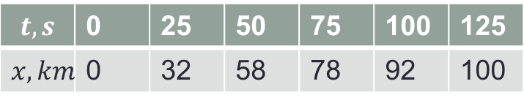

1. Estimate velocity at $t=25$ using two point forward difference formula/ forward difference formula of $o(h)$.
2. Estimate velocity at $t=50$ using three point central difference formula/central difference formula of $o(h^{2})$.
3. Estimate velocity at $t=125$ using three point backward difference formula/ difference formula of $o(h)$.

## Code:

%Q1

X = [0,25,50,75,100,125];

Y = [0,32,58,78,92,100];

h = X(2)-X(1)

%Part a: two point forward difference formula at t = 25

v_at_25 = (Y(3) - Y(2))/h

%Part b: three point central difference formula at t = 50

v_at_50 = (Y(4)-Y(2))/(2*h)

%Part c: three point backward difference formula at t = 125

v_at_125 = (3*Y(6)-4*Y(5)+Y(4))/(2*h)

## Output:

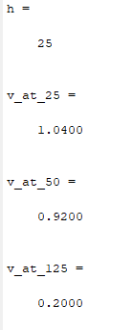

1. Consider the following table of values.

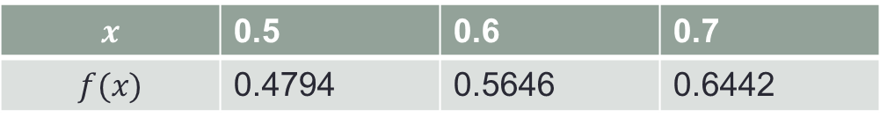

1. Estimate $f^{''}(0.6)$ using central difference formula of $o\left(h^{2}\right)$.
2. If $f\left(x\right)=sinx$ then calculate error bound of central difference formula of $o\left(h^{2}\right)$.

## Code:

%Q2

X = [0.5,0.6,0.7];

Y = [0.4794, 0.5646, 0.6442];

h = X(2) - X(1)

a = (Y(3) + Y(1) -2*Y(2)) /(h^2)

x = 0.7;

f = sin(x);

e = (h^2)/12 * f

## Output:

